**Dataset description**

**Size:** (3678859, 7)

Data columns (total 7 columns):

# Column Dtype

--- ------ -----

0 FL_DATE object

1 OP_CARRIER object

2 ORIGIN_CITY_NAME object

3 CRS_DEP_TIME int64

4 DEP_TIME float64

5 DEP_DELAY float64

6 FLIGHT_DELAY_LEVEL int64

dtypes: float64(2), int64(2), object(3)

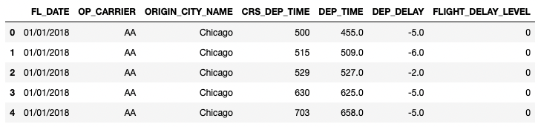

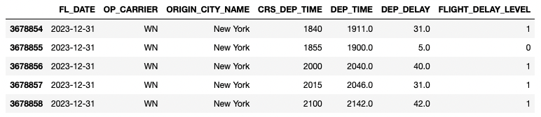

**FL_DATE:** dd/mm/YYYY date type

**OP_CARRIER:** Total 8 Airlines ['DL', 'WN', 'UA', 'G4', 'AA', 'NK', 'F9', 'B6']

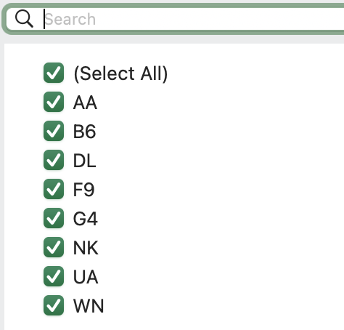

**ORIGIN_CITY_NAME:** Total 4 cities ["New York", "Los Angeles", "Chicago", "Houston"]

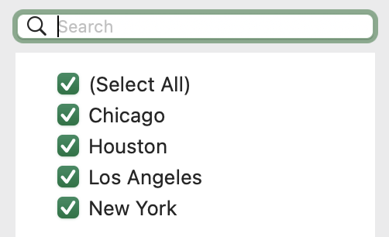

**DEP_DELAY:** DEP_TIME – CRS_DEP_TIME

**FLIGHT_DELAY_LEVEL:**

DEP_DELAY<15 == 0

15 <= DEP_DELAY<45 == 1

45 <= DEP_DELAY<75 == 2

75 <= DEP_DELAY<105 == 3

105 <= DEP_DELAY<135 == 4

135 < DEP_DELAY == 5